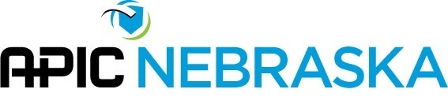
Linda Horning National Education Scholarship Application
Award: The winning applicant will receive a check for the early bird registration for the National APIC Conference (made payable to National APIC). The winner will be notified. A formal recognition will be made at the annual APIC Nebraska Meeting in March.
Purpose: To provide an opportunity for members to attend the national conference and to stimulate future involvement in the local and national organization.
Eligibility: Members are not eligible to receive the award for two consecutive years. Board members receiving financial support from the chapter to attend the national conference are not eligible for this award.
Criteria: The applicant must:
- Be a member of APIC Nebraska.
- Have all meetings attended documented on a sign-in sheet.
- Agree to present their impressions and reactions from the national conference at a chapter meeting or APIC Nebraska sponsored conference
- Applicants who have served on a committee, task force, or the APIC Nebraska Board within the last 5 years will be given preferential consideration.
- Members may apply themselves

Application: Complete the application below and attach a written statement that describes your financial need and your plans for how will become more involved in the APIC Nebraska Chapter after you return from the conference. The complete application must be submitted to the chair-person of the awards committee No later than February 3rd.
Name |  |  | Employer
APIC Nebraska member since |  |  | Email
Percent of meetings attended/viewed in the last 12 months: |  | Have you received this scholarship in the past, if so state the year(s)
List all committees, task forces, and board memberships with the dates of service:

I am willing to present my impressions from the conference and a summary of selected educational topics to the membership at Professional Growth Day.
Signature: ______________________________________________________
Return via email to Lindsy Kroenke lkroenke@madonna.org

